NEWS TIME Saturday May 30 1987

The rape of a virgin forest

Tales from Bison Hills-I

From John Ulahannan in Chintalapudi

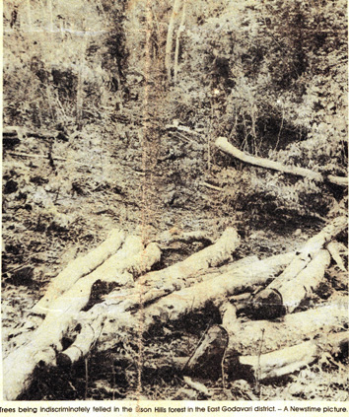
The virgin forests of the Bison Hills of East Godavari district are now under a shave-off threat as the unscrupulous, scheming timber contractors spread their tentacles deeper and deeper into the rich groves. They grab from the treasure box of nature in broad daylight and get away with the loot as the helpless, and in many cases conniving, authorities watch indifferently.

This reporter, recently on a tour of the agency areas of East Godavari district, witnessed with the help of some local and deforestation activists the virtual rape of a virgin piece of natural forest, rare in Andhra Pradesh, at the hands of a timber contractor based at Kakinada. His men are busy cutting down trees and what today is a stretch of lovely forest cover will soon turn into barren land. The place in question is about 25 km from the road head at Maredumilli off Rampachodavaram, Sileru and Narsipatnam to Chintur constitute Andhra Pradesh’s only stretch of natural forests, quite rich, through not as rich as the Silent Valley in Kerala, in flora and fauna. The wild species of bison found in these forests has earned them the name Bison Hills.

The story begins with the granting of pattas to 11 non-tribal individuals from Kakinada for 11 separate but adjacent plots of non-reserve forest land here bearing survey numbers from 51/1 to 51/11 some years back. The lands stretch across the Chitapkonda and Kakibandalu hills overlooking the Chintalapudi tribal settlement of Y Ramavaram mandal. The grant of these pattas itself is questionable because non-tribals are not entitled to hold landed property is scheduled areas according to the Land Translation Regulation Act of 1974. But the parties concerned, it is learnt, took advantage of the provisions of another Act of the state government which in a way nullify the LTRA restrictions on land holdings in scheduled areas by non-tribals. The Act legalises the issuance of “Ryotuvaripattas” to lands to non-tribals if they had been cultivating such lands in scheduled non-reserved forests for eight years. But the lands in question were obviously never under cultivation. These lands are virgin forests unexplored and rich in natural beauty and forest wealth. Acting on a complaint about the pattas, the Director of Settlements, Revenue Department, ordered the cancellation of the same but the higher authority, the settlement commissioner, reversed the order on the technical ground of time delay, it is learnt.

As the pattas were cleared the 11 non-tribals conferred the power of attorney with regard to the use of these forest lands on a timber contractor and dealer from Kakinada. The power of attorney entitles the person concerned to solely and totally exploit the resources available in the land in question like cutting and selling trees, etc. The contractor brought in his men and set up work comps in the deep forest and started felling trees on a large scale. But the tribal population of the surrounding areas, especially those of Chintalapudi settlement who would be the most affected in the case of the said forest being wiped off, raised pociferous objections with the help of certain social activists. The sarpanch of the Chintalapudi village told me that the contractor in a bid to settle the issue before it spilled out from the confines of the forest offered to pay a community compensation of Rs. 6,400 on each plot of land for all the 11 survey numbers to the tribals. But the tribals refused the compensations as they considered this would be the gravest sin they could commit selling off the sustenance of their existence, mother forest.

However, as I had pointed out earlier, the contractor is going ahead with his operations. Deep into the valleys and the cliffs of this unwalked forest his men have now laid truck roads. Hundreds of workers are engaged in cutting trees. And many others in pulling them down truck roads using buffaloes. At Many places there are stacks waiting to be lifted by trucks. The tribals and the social activists who campaign against deforestation in these areas have almost lost the bottle against this ecological outrage under the nose of the Forest Department, as they are left unarmed against the might of the contractor. Sources who have sought anonymity allege that right them the stage of the issual of pattas the contracter has been invoiced in the matter. They argue that otherwise there was no need for all the 11 patta-holders to confer the power of attorney on the same contractor.

Sources say that similar shaving of virgin non-reserved forests is taking place at four other places in the agency areas of east Godavari district.

The Chintalapudi scandal raises certain questions. How could the settlement department clear pattas on forest lands without proper enquiries, on the pretext that the lands in question were agricultural lands whereas the truth is otherwise. Why did the Forest Department, which claims to be the guardian of all forests not object to the issuance of the pattas as well as the subsequent felling of trees by the contractor. Why should the contractor affer to compensate the tribals if the whole affair was legal. The government owes the answers to these questions to the people of a state which experiences he alarming consequences of ecological deterioration more and more as each day passes.

